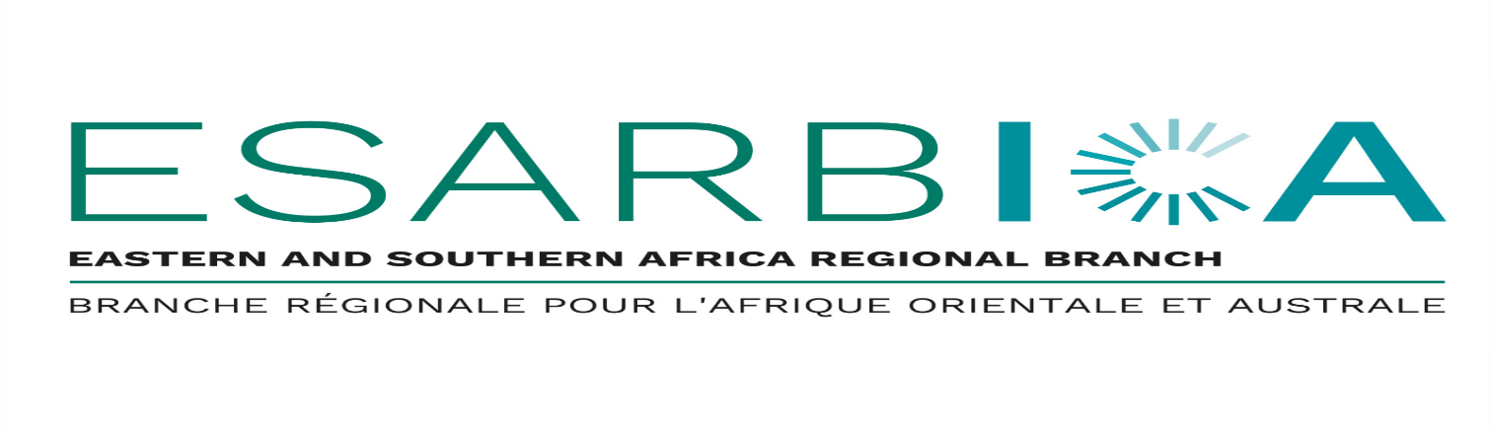
FULL PROGRAMME OF EVENTS IN LESOTHO
1. Mon & Tuesday 20-21st July 2026: Executive Board meeting
2. Wednesday 22nd July: Excursion (Board members)
3. Wed, Thursday & Friday 22, 23 & 24th July: Training
4. Saturday 25th July – DEPARTURE

ESARBICA TRAINING PROGRAMME - LESOTHO 2026
This training programme is designed as a refresher course for archives and records management professional in the ESARBICA region. Participants will include three categories:
- Beginners: those working in records/archives management (RAM) with no formal training, and may need basic/theoretical training for a start. This should appetize them to seek formal training at our universities/colleges.
- Technical: those people working in RAM with formal training, but need capacity building on digital records management. This is anticipated to be the largest of the three participants.
- Leadership/ Management: leadership of RAM departments who need strategic training on advocacy, project leadership/management, strategic alignment, etc.
Member countries are expected to nominate participants. For each training session, each country is expected to nominate 3 – 5 participants. Where 5 or more participants &are nominated, the nominees will receive a10 % discounted price of the fee.
Intended Audience | - Records managers / Records officers  - Archivists  - Data protection officers  - Documentation officers  - Information officers  - Information technology (IT) officers  - Knowledge officers / managers  - Policy makers / directors / managers  - Librarians  - Anyone handling records / information in their daily work

GOALS
The training / workshop series will be designed around different themes to address records and archived-related needs in member countries in the ESARBICA region. The training is set to archive the following objectives:

- Produce capacitated and skilled employees able to professionally work in an archives and records management environment;
- Produce employees who can advocate for records management to their employers and get the necessary support to develop policies and records management procedures such as classification systems; retention and disposition schedules and guidance on the management of specialised records such as legal records; health records, architectural records, financial records
- Produce leadership that can buy-in and support ARM programmes.
- Fosters the development of records and archive managers who will assume an assertive role in preserving and servicing the records and archives industry/profession;
- Provide direction for the future development of the field of records and archives management , especially impact of technology and AI on the profession
- Promote commitment to continuous professional development and growth to meet the new and everchanging roles of records, archives and information practitioners.

VENUE | : Maseru Avani Hotel
DATES | : 23; 24 & 25th July 2026
COST: | : USD 250 per participant. Member countries sending more than 5 participants will get a 10% discount for each participant.
DAY 1: Wednesday 23rd July 2026
TIME | TOPIC | FACILITATOR
8:00 – 8:30 | Registration and Introductions | ALL
8:30 – 10:00 | - Overview  - Introduction to the records management practice  - Importance of managing records  - Challenges in the management of records  - Regulatory frameworks and standards | Facilitators  (supported by Editors Dr S. S. Keakopa & Dr M. Masuku)
10:00 – 10:30 | HEALTH BREAK | ALL
10:30 – 12:45 | - Managing current, semi & non-current records  - Records Management Unit (RMU) / Registry  - Records management policies and procedures  - Mail and files management  - Appraisal, retention and disposition | Mr Andile Maseko  Eswatini Revenue Authority  (supported by Editors Dr S. S. Keakopa & Dr M. Masuku)
12: 45 – 14:00 | LUCH BREAK | ALL
14:00 – 16:00 | - Archiving & archives administration  - Security of records  - Resource implications | Dr Godfrey Tsvuura  Zimbabwe Open University
 | WRAP UP FOR DAY 1 | ALL
Day 2: 24th Thursday July 2026
TIME | TOPIC | FACILITATOR
8:00 – 8:30 | Registration and Introductions | ALL
8:30 – 10:00 | - Vital records & disaster management | Facilitators (BOTH)
10:00 – 10:30 | HEALTH BREAK | ALL
10:30 – 12:45 | - Developing & implementing a records management programme  - Change management  - New and changing roles of archivists today: reskilling and upskilling | Mr Andile Maseko  Eswatini Revenue Authority (ERA)  (supported by Editors Dr S. Keakopa & Dr Masuku)
12:45 – 14:00 | LUCH BREAK | ALL
14:00 – 16:00 | - Digital preservation, digital preservation software e.g Preservation cloud computing and records management; ownership of records in digital spaces  - Electronic Documents and Records Management Systems (EDRMS) and Enterprise Content Management (ECM) systems | Dr Godfrey Tsvuura  Zimbabwe Open University  (supported by Editors Dr S. Keakopa & Dr M. Masuku
 | WRAP UP FOR DAY 2
DAY 3: Friday 24th July 2026
TIME | TOPIC | FACILITATOR
8:00 – 8:30 | Registration and Introductions | ALL
8:30 – 10:00 | - Managing electronic records  - Impact of ICTs: AI, big data, blockchain & other technologies  - Characteristics of electronic records  - Regulatory environment and standards | Dr Godfrey Tsvuura  Zimbabwe Open University  (supported by Editors Dr S. Keakopa & Dr M. Masuku)
10:00 – 10:30 | HEALTH BREAK | ALL
10:30 – 12:45 | - Practical demonstration of EDRMS/ECM systems  - Introducing different records, archives and information management software and vendors in the market  - Demonstration of software | Facilitators (BOTH)  (IT Partners)  (supported by Editors Dr S. Keakopa & Dr M. Masuku
12: 45 – 14:00 | LUCH BREAK | ALL
14:00 – 15:00 | ISSUING OF CERTIFICATES; NETWORKING | President, ESARBICA

Registration Form
Name: …………………………............ | Surname:………………………………….
Position:………………………………. | Organisation:…………………………….
Tel:…………………………………...... | Email:……………………………………….

Registration Fees (VAT Inclusive) | USD 250 PER PARTICIPANT  10% discount each for 5 or more participants from the same institution)  Price includes: Venue, training material, and certificate)
To register complete this form and send it to esarbica2021@gmail.com/ fosotm@gmail.com
For further information and enquiries contact
Contact Person: Segomotso Keakopa / Thapelo Foso / Rose Kaibe
Tel : + 267 74340175 / + 26662255225/+26658998799
Email : esarbica2021@gmail.com / fosotm@gmail.com/ rose.kaibe@gov.ls

Banking Details
BANK NAME: ABSA Bank Botswana
Account Name | ESARBICA
Account Number | 1265103
Branch Code | 290167
SWIFT CODE | BARC BWG, Gaborone, Botswana
Branch Name | MALL BRANCH

